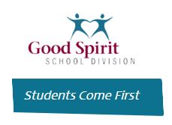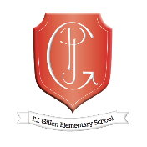**PJ Gillen School Community Council Norms**

We will be solution focused.

We will be open to doing things differently.

We will be student centered.

We will adhere to Administrative Procedure 110 – School Community Councils.

We will send out information prior to meeting.

We will adhere to start and end times.